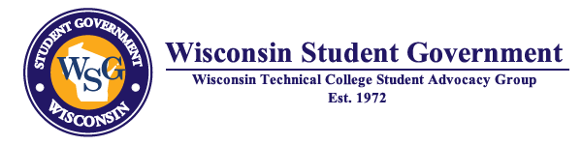
2021-2022 WSG MEETINGS

Due to recovering from the COVID-19 pandemic and the decision by the colleges to restrict travel of staff and students, Wisconsin Student Government will plan to conduct its October and November meetings in a virtual format. The 2022 meetings are being planned for in-person as well as the Legislative Seminar. Should conditions change and the format would change, the Executive Team would make this decision and host colleges will be notified in advance. Virtual meetings will begin at 9:00 a.m.

October 8, 2021 – Virtual Meeting – hosted by Southwest Wisconsin Technical College

November 12, 2021 – Virtual Meeting – Northeast Wisconsin Technical College

January 7, 2022 – Meeting and Potential Leadership Training -- Hosted by Northcentral Technical College

February 20-22, 2022 –Legislative Seminar, Madison Concourse

April 8, 2022 –Meeting hosted by Western Technical College

- Each hosting college will supply the platform to host the virtual meeting.

- On-site meetings will include lunch and will receive a stipend.

- Each meeting will include a 3-5 minute virtual tour of the hosting college. If on-site a 10-15 minute tour of an area on campus will be included.

- Each meeting will include a virtual or on-site visit from a legislator scheduled by the host school with a representative from the college district.

