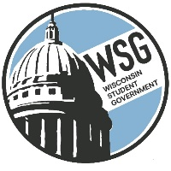
Wisconsin Student Government
Wisconsin Technical College Advocacy Group
Established 1972
www.wsgtech.com

Wisconsin Student Government
Legislative Seminar
February 20-22, 2022
Madison Concourse
Important Deadlines and Information

Lodging

Madison Concourse – 1 West Dayton Street, Madison WI
Concourse Premier Level -- $124.00 for Single/Double/Triple/Quad
Governor’s Club Level -- $224.00 for Single/Double/Triple/Quad

Room Blocks are requested to be submitted by December 15, 2021
Rooming Lists to the Madison Concourse by January 25th, 2022
Reservation Cut-off Date is Tuesday, January 25, 2022

Reservations can be made by calling 800-356-8293 and ask for the 2022 Wisconsin Student Government Legislative Seminar. Courtney from Group Reservations is your contact.

Registration Deadline

Wednesday, February 2 – Registration form deadline to be submitted to Vicky Weiland, WSG Resource Director

Registration will need to include food choice for banquet and t-shirt size.

Registration fees can be submitted at the seminar or sent to Vicky Weiland, WSG Resource Director, N5172 Woodhaven Court, Shiocton WI 54170

