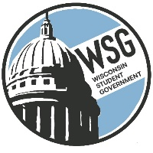
Wisconsin Student Government
Wisconsin Technical College Advocacy Group
Established 1972
www.wsgtech.com

2022-2023 WSG Executive Team Goals

- WSG will promote organization and advocacy positions using the social media platforms of Instagram, Twitter and Facebook.
- WSG will actively engage with WISCORE and other state events to visibly promote the organization and its advocacy positions.
- WSG will seek continuous improvement throughout the year by:
  - Having all 16 colleges attend a minimum of two meetings and increase their participation at the Legislative Seminar.
  - Providing more opportunities for the Governors to actively engage in WSG activities.
  - Create a smooth transition for the new Resource Director.

