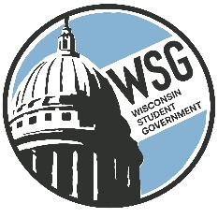
Wisconsin Student Government
Wisconsin Technical College Advocacy Group
Established 1972
www.wsgtech.com

WSG Advocacy Positions
2022-2024

Investment in OER (Open Educational Resources)

Investment in Wisconsin Grants and amend state statutes to align with the Federal Pell Grant

State statute requiring a current student and/or alumni, within the prior 5 years, to serve on the local District Board of each of the 16 technical colleges.

