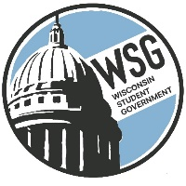
Wisconsin Student Government
Wisconsin Technical College Advocacy Group
Established 1972
www.wsgtech.com

AGENDA
February 19, 2023
Madison Concourse

5:00 p.m. Roll Call
Technical College |  | Technical College
Blackhawk |  | Moraine Park
Chippewa Valley |  | Nicolet
Fox Valley |  | Northcentral
Gateway |  | Northeast WI
Lakeshore |  | Northwood
Madison |  | Southwest
Mid-State |  | Waukesha
Milwaukee Area |  | Western
5:05 p.m.
- Welcome – Katrina Willis, WSG President
- Approval of Agenda and January 13, 2023 Minutes
- Reports
  - President’s Report – Katrina Willis
  - AFO Report- John Krueger
  - Resource Director- Katie Brooks
    - 2023-2024 Proposed Budget – 2nd Review (approval at the April 14th meeting)
    - Next meeting, April 14 hosted by Mid-State
- Position Paper- Patrick Casper
- WSG Updates- Brandon Trujillo
  - Bylaws
  - Prep for Monday & Tuesday
- WSG Officer Election in April- Katie Brooks
  - Duties of officer positions
  - Election Criteria
  - Officer Testimonials
- Governor Reports
6:00 p.m. Adjourn

