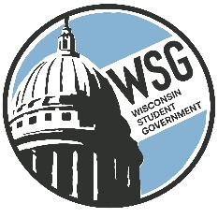
Wisconsin Student Government
Wisconsin Technical College Advocacy Group
Established 1972
www.wsgtech.com

WSG January 12, 2024 Meeting
Hosted by Northcentral Technical College
1000 W. Campus Drive | Wausau, WI 54401
Room: Center for Health Sciences-Room 1004

10:00 a.m. Roll Call

Technical College |  | Technical College
Blackhawk |  | Moraine Park
Chippewa Valley |  | Nicolet
Fox Valley |  | Northcentral
Gateway |  | Northeast WI
Lakeshore |  | Northwood
Madison |  | Southwest
Mid-State |  | Waukesha
Milwaukee Area |  | Western

10:05 a.m. Welcome from Katie Felch, Vice President of Community + Government Relations.

10:15 a.m. Approval of Agenda and November 10 Meeting Minutes

Reports
  - President Report – Katrina Willis
    - Guiding Principles
  - AFO Report – Kai Brito
  - Resource Director Report
    - Legislative Seminar Updates
    - Content Manager Introduction

10:45 a.m. WTCS Updates- Brandon Trujillo – WTCS Policy Advisor

11:00 a.m. Legislative Seminar Position Paper- Brandon Trujillo/Madison/Nicolet

11:45 a.m. Fundraising Work Group Updates- John Krueger

12:15 p.m. – Lunch

1:00 p.m. Legislative Representative Visit – Representative Patrick Snyder

2:00 p.m. Governor Updates

2:30 p.m. Adjournment

