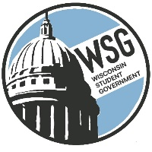
Wisconsin Student Government
Wisconsin Technical College Advocacy Group
Established 1972
www.wsgtech.com

AGENDA
February 18, 2024
Madison Concourse

5:00 p.m. Roll Call
Technical College |  | Technical College
Blackhawk |  | Moraine Park
Chippewa Valley |  | Nicolet
Fox Valley |  | Northcentral
Gateway |  | Northeast WI
Lakeshore |  | Northwood
Madison |  | Southwest
Mid-State |  | Waukesha
Milwaukee Area |  | Western
5:05 p.m.
- Welcome – Katrina Willis, WSG President
- Approval of Agenda and January 12, 2024 Minutes
- Reports
  - President’s Report – Katrina Willis
  - Vice President- WSG Introduction- Mailia Bachleitner
  - AFO Report- Kai Brito
  - Parliamentarian Overview- Carl Van Caster
  - Resource Director- Katie Brooks
    - Results of Poll
    - Next meeting, April 12 hosted by Mid-State
- Governor Reports
6:00 p.m. Adjourn

